2021

Planning & Management

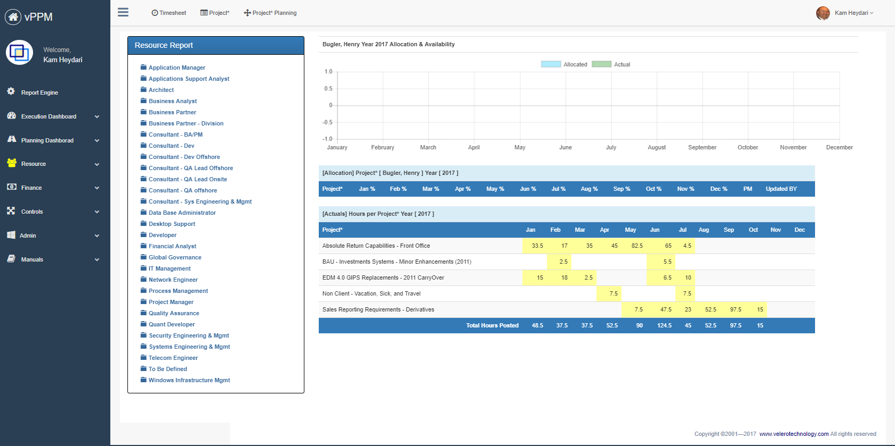

**Student Names:**

Shemal Shah

**Assignment Name:**

Spotify

Contents

2. Company Strategy & Scorecard 2

2.1. Company Background 2

2.2. SWOT Analysis 2

2.3. Scorecard 3

2.4. Reference information 4

3. Project Definition 4

3.1. Project Business Case 4

3.1.1. Project overview 4

3.1.2. Business issues/opportunities 4

3.1.3. Project Business Goals 5

3.2. Primary Project Objectives 5

3.3. Project Benefits 5

3.4. Primary Project Deliverables 6

3.4.1. Project milestones 6

3.4.2. Project Interdependencies and Inputs 6

3.5. Project Conditions 7

3.5.1. Assumptions 7

3.5.2. Risks and Issues 7

3.5.3. Project Constrains 7

3.6. Project Critical Success Factors (Key Performance Indicators) 8

3.7. Scope 8

3.8. Strategy Matrix 9

3.9. Work Breakdown Structure 10

3.10. Resource and Cost Estimate 10

3.10.1. Cost 10

3.10.2. Resource Needed 11

3.11. Roles & Responsibility Matrix 12

3.12. Project Structure 13

3.13. Resource requirement Matrix 14

3.14. Project Schedule 15

# Company Strategy & Scorecard

## Company Background

* Spotify is a company,Where it’s easy to find the right music or podcast for every moment on your phone, your computer, your tablet and more.
* There are 70 million plus tracks and episodes on Spotify. So whether you’re driving, working out, partying or relaxing, the right music or podcast is always at your fingertips.
* 155M subscribers and 345M active lisyeners

## SWOT Analysis

|  |  |
| --- | --- |
| Strength   * **It carries a strong brand reputation.** * **Spotify’s technology does a great job of personalizing your music selection.** * **The pricing structure is simple and provides easy entry.** * **Spotify boasts an expansive music library.** | Weakness   * **Licensing fees result in high royalty costs for Spotify.** * **Streaming requires an Internet connection.** * **It is very similar to other music streaming apps.** |
| Opportunity   * **New markets are ripe for expansion.** * **A big investment in video streaming could be the next step.** * **Spotify could continue to push hard to corner the podcasting market.** | Threats   * **Spotify still has not made a profit.** * **With millions of podcasts Misinformation could spread quickly** * **There are continued legal disputes over streaming rights.** * **Spotify is vulnerable to piracy.** |

## Scorecard

## Reference information

* <https://www.spotify.com/us/about-us/contact/>
* <https://s22.q4cdn.com/540910603/files/doc_downloads/2021/Spotify_2020-Sustainability-Report_US_Format_FINAL_signature2.pdf>

# Project Definition

Project Name: Restrict and Verify Fake news spread over Podcast

## Project Business Case

### Project overview

Spotify transformed music listening forever when it launched in 2008. Discover, manage and share over 82 million tracks, including more than 3.6 million podcast titles, for free, or for Spotify Premium to access exclusive features for music including improved sound quality and an on-demand, offline, and ad-free music listening experience. Today, Spotify is the world’s most popular audio streaming subscription service with 406m users, including 180m subscribers, across 184 markets. With more than 3M podcasts in its library Spotify is a book of knowledge to many people, which leads to the biggest problem it is facing is the misinformation that is spread through it.

### Business issues/opportunities

* Put advisory and marks on podcast which could be spreading misinformation
* Demonetize podcasts that fail to give accurate information
* Establish a team to discuss and form Rules
* Ban them from the Spotify service
* Create an AI which can automatically detect fake news

### Project Business Goals

|  |  |
| --- | --- |
| ID | Objective/Goal |
| O1 | Have all the podcasts in the library verified |
| O2 | Regain the trust of subscribers |
| 03 | Have a powerful AI which can remove and misinformation that is spread by Our service |

## Primary Project Objectives

* Have a set of rules and guidelines that everyone should follow
* Removing and censoring old podcast that could still lead to mis information
* Regain the trust of subsribers

## Project Benefits

* No misinformation should spread through Spotify Service
* Have An AI that can control over the inspection
* With decrease in fake news Spotify will be less vunreable to legal disputes

## Primary Project Deliverables

### Project milestones

|  |
| --- |
| Market Research |
| * Figure out how many use podcast for real information and news * Will people reduce watching podcasts if it is filled with fake news * Find out who are the biggest offenders |
| Internal |
| * Establish Rules and guidelines * Verify all the podcast in the library * Start banning podcasts who fail to comply |
| AI |
| * Demo of how accurately it verifies the information * How it should be implemented * What constraints its should have |

### Project Interdependencies and Inputs

|  |
| --- |
| Project Interdependencies and Inputs |
| * Guideline and Misinformation * Subscriber trust and retention * Machine learning teams that introduce new algorithms and AIs |

## Project Conditions

Includes your project assumptions break them down by (resources, delivery, budget, scope, schedule, methodology, technology, and architecture & design)

### Assumptions

[Identify all known assumptions that apply to this project.]

| **ID** | **Item** |
| --- | --- |
| A1 | This project works with internal flights Because Internet access is available on internal flights so that the customer can track the bag |
| A2 |  |
| A3 |  |
| A4 |  |

### Risks and Issues

Identify risks and issues in the following forms.

|  |  |  |  |
| --- | --- | --- | --- |
| **Risk** | **Prob** | **Impact** | **Mitigation** |
|  |  |  |  |
|  |  |  |  |
|  |  |  |  |
|  |  |  |  |
|  |  |  |  |

### Project Constrains

[Replace this text with an outline of all known constraints that apply to this project.]

## Project Critical Success Factors (Key Performance Indicators)

[Replace this text with an outline of all known critical success indicators that apply to this project.]

## Scope

Define what is in- and out- of scope for your project.

#### In scope

**Sample**: The In-Scope functions will be assessed from both an interim and future state perspective, incorporating the specific organization complexities relative to global lines of business, asset classes, reporting, and operational processes. The following capabilities are agreed to be in-scope for the data assessment and target state design:

| **ID** | **Type** | **Definition** |
| --- | --- | --- |
| S1 | Customer | Definition of what is in the project scope as far as customer is concerned |
| S2 | Airline |  |
| S3 | Inventory |  |

#### Out of Scope

**Sample**: The following areas are agreed to be out of scope for the Data Assessment:

| **ID** | **Item** |
| --- | --- |
| OS1 | Organization changes … |
| OS2 |  |
| OS3 |  |

## Strategy Matrix

Define complete strategic matrix for your project using strategic matrix table – Identify 4 strategies for the organization – See lecture material and PMI material.

|  |  |  |  |  |
| --- | --- | --- | --- | --- |
| Project Objectives | Strategies | | | |
| **Strategy** | **Strategy** | **Strategy** | **Strategy** |
|  |  |  |  |  |
|  |  |  |  |  |
|  |  |  |  |  |
|  |  |  |  |  |
|  |  |  |  |  |
|  |  |  |  |  |
|  |  |  |  |  |

## Work Breakdown Structure

Define your work breakdown structure for your project – See Lecture material

## Resource and Cost Estimate

Using the following format define your resource (Excluding FTE Cost) cost estimates.

### Cost

|  |  |  |  |
| --- | --- | --- | --- |
| Cost Description | Schedule (year) | Amount | Note |
|  |  |  |  |
|  |  |  |  |
|  |  |  |  |
|  |  |  |  |
|  |  |  |  |
|  |  |  |  |

### Resource Needed

|  |  |
| --- | --- |
| Resource Type | Note |
|  |  |
|  |  |
|  |  |
|  |  |
|  |  |
|  |  |

## Roles & Responsibility Matrix

Define roles and responsibilities using RACI model for all participating resources.

|  |  |  |  |  |  |  |  |  |  |
| --- | --- | --- | --- | --- | --- | --- | --- | --- | --- |
| **Project Team**  **|**  **Area of Responsibilities** | |  |  |  |  |  |  |  |  |
|  |  |  |  |  |  |  |  |  |  |
|  |  |  |  |  |  |  |  |  |  |
|  |  |  |  |  |  |  |  |  |  |
|  |  |  |  |  |  |  |  |  |  |
|  |  |  |  |  |  |  |  |  |  |
|  |  |  |  |  |  |  |  |  |  |
|  |  |  |  |  |  |  |  |  |  |
|  |  |  |  |  |  |  |  |  |  |
|  |  |  |  |  |  |  |  |  |  |
|  |  |  |  |  |  |  |  |  |  |
|  |  |  |  |  |  |  |  |  |  |
|  |  |  |  |  |  |  |  |  |  |
|  |  |  |  |  |  |  |  |  |  |
|  |  |  |  |  |  |  |  |  |  |
|  |  | R | A | C | I |  |  |  |  |
|  |  |  |  |  |  |  |  |  |  |
| **Responsible** | | People or stakeholders who are the "doers" of the work. They must complete the task or objective or make the decision. Several people can be jointly *Responsible*. | | | | | | | |
| **Accountable** | | Person or stakeholder who is the "owner" of the work. He or she must sign off or approve when the task, objective or decision is complete. This person must make sure that responsibilities are assigned in the matrix for all related activities. ***Success requires that there is only one person Accountable.*** | | | | | | | |
| **Consulted** | | People or stakeholders who need to give input before the work can be done and signed-off on. These people are "in the loop" and active participants. | | | | | | | |
| **Informed** | | People or stakeholders who need to be kept "in the picture." They need updates on progress or decisions, but do not need to be formally consulted, nor do they contribute directly to the task or decision. | | | | | | | |

## Project Structure

Define your project structure considering information provided in the project mandate.

## Resource requirement Matrix

Define resource requirement matrix per work pages using the format that was provided to you in the class and for your group assignment.

|  |  |  |  |  |  |  |  |  |  |  |  |  |
| --- | --- | --- | --- | --- | --- | --- | --- | --- | --- | --- | --- | --- |
| Resource/Month | 1 | 2 | 3 | 4 | 5 | 6 | 7 | 8 | 9 | 10 | 11 | 12 |
|  |  |  |  |  |  |  |  |  |  |  |  |  |
|  |  |  |  |  |  |  |  |  |  |  |  |  |
|  |  |  |  |  |  |  |  |  |  |  |  |  |
|  |  |  |  |  |  |  |  |  |  |  |  |  |
|  |  |  |  |  |  |  |  |  |  |  |  |  |
|  |  |  |  |  |  |  |  |  |  |  |  |  |
|  |  |  |  |  |  |  |  |  |  |  |  |  |

Using Velero product include the estimated cost (Screen shot)

## Project Schedule

Using the following format to define complete project schedule using PMI (initiation, Planning, Execution, Monitoring and Control and Closure.) Start date 1/1/2022. Make your project schedule as realistic as possible please. Identify all the dependencies, using task ID.

Input the information into Velero and generate the Gantt chart. Include the Gantt chat screen shot.

|  |  |  |  |  |  |
| --- | --- | --- | --- | --- | --- |
| Task ID | PMI | Tasks/Milestone | Start | End | Dependency |
| 1 | Initiation |  | 1/1/2020 |  |  |
|  |  |  |  |  |  |
|  |  |  |  |  |  |
|  |  |  |  |  |  |
|  |  |  |  |  |  |
|  |  |  |  |  |  |
|  |  |  |  |  |  |
|  |  |  |  |  |  |
|  |  |  |  |  |  |
|  |  |  |  |  |  |
|  |  |  |  |  |  |
|  |  |  |  |  |  |
|  |  |  |  |  |  |
|  |  |  |  |  |  |
|  |  |  |  |  |  |